**Section 61: The New Toughness of Mind: Realism, Positivism, Marxism**

* Humane nationalism, liberalism without violence, peaceful and democratic commonwealth, national liberty, unification of national groups

**Toughness of mind prevails**

*Romanticism discredited, revolutionaries less optimistic, conservatives more willing to use repressive measures.*

It was now a point of pride to be REALISTIC!

**Wins**

* Constitutional Government – more secure in what countries?
* Peasantry emancipated in German states and the Austrian Empire
* ____________ abolished

Auguste Comte

* 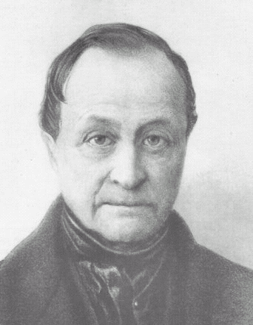Define **Positivism:**

Realpolitik – new toughness of mind in politics

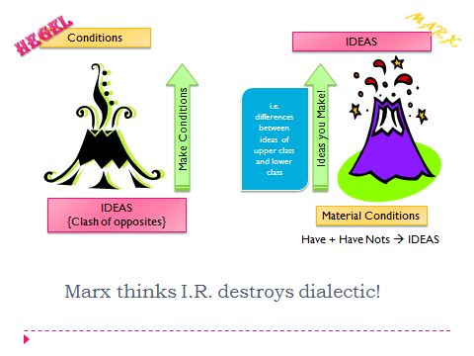

* Define **Historicism:**

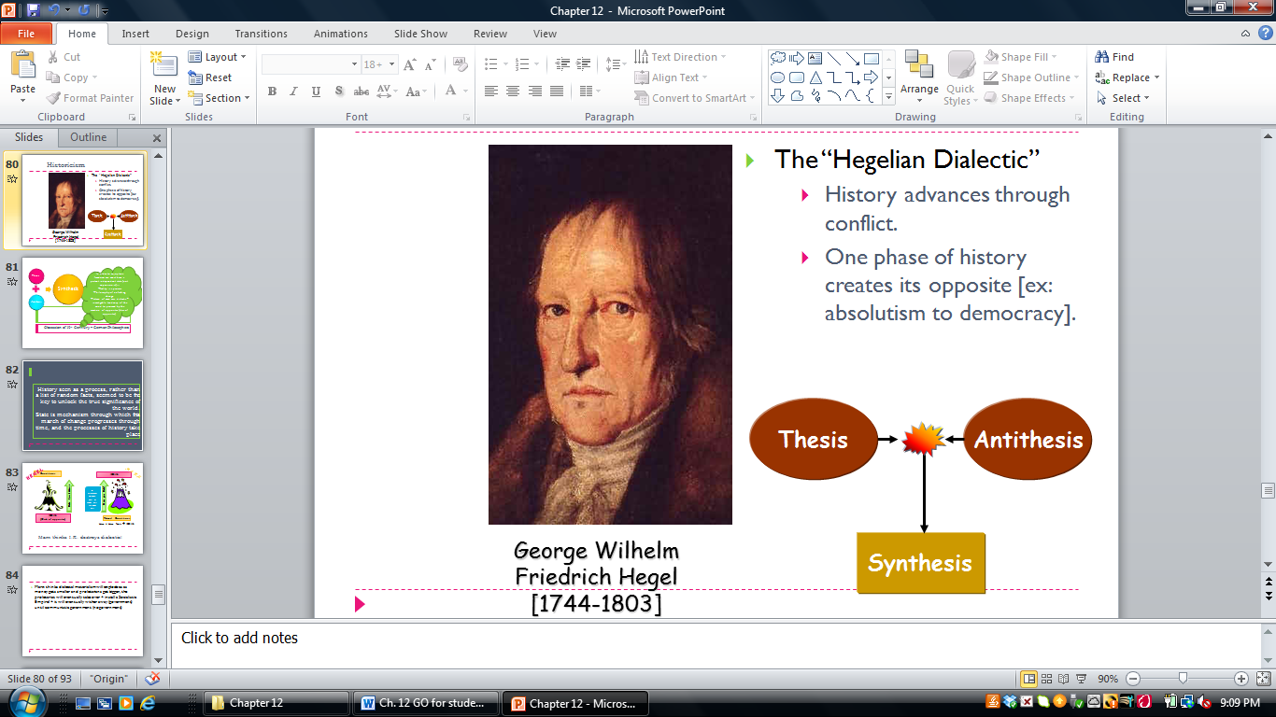

# Ch. 23 – Unification

Napoleon III – popular in name

~ **Bonapartism: The Second French Empire, 1852 – 1870 ~**

* Who is appointed to recreate the city of Paris?

Unification

In the mid-19th century, nationalism was a romantic movement. However, _______________ began to replace romanticism. During the late 19th century, European leaders began to practice ______________, or the “politics of reality”. As nationalism grew in strength, the balance of power that was created at the _______ ___ _______ was destroyed. Wars were fought between the Great Powers of Europe from 1854-1871 because of their conflicting goals:

France:

Germany and Italy:

Austria:

**Unification of Italy**

As a result of the Congress of Vienna, Italy was under foreign control, with the exception of the native-ruled Kingdom of _________. Italian nationalists, increasingly taken by the romantic dream of the Italian _________________ that recalled the glory of Rome and the Renaissance, looked this state for leadership. Since 1848, this nation was a constitutional monarchy led by _______________ ________________ ____ who chose as his PM a man named _________________________ ____ _____________. This PM was a liberal, and a champion of realpolitik, thus he opposed the nationalist republicans, but did make a united Italy his top priority.

The greatest obstacle to Italian unity was _____________. To get help against this country, Cavour turn to _________________ of France. This man was slow to support Cavour, but was “persuaded” in 1859. In April, _______went to war with a combined French-Sardinian force. This was a short war since Napoleon III feared the Prussians, the Italian revolutions, and also had a conflict of interest in Rome. The result was that France made peace with ____________ in July of 1859. These agreements were made during that peace:

1.

2.

3.

4.

After Cavour was finished annexing northern Italy, _____________ led a group of Italian nationalists known as ___________________ ______________________ in an armed expedition to the south, which was very successful because the ____________ of ___________ collapsed. Avoiding the French armies protecting the Pope in Rome, the Red Shirts and the Piedmontese armies met in Naples in 1861 for an Italian parliament. They declared Victor Emmanuel II as a ________________________ ________________________.

In 1866 _______________ was added to the Kingdom of Italy as a prize for helping Prussia against Austria.

In 1870, the rest of _____________ was added when French troops withdrew during the **Franco-Prussia War**. The Pope, in protest, remained within the walls of the Vatican until ________.

The unification of Italy was a triumph for Italian nationalists; however, it resulted in many problems as well. Some kept claim to other “Italian” areas, referring to them as the _______________. The rift between the church and the state grew wider. There was great tension between the ______________________ north and the ________________ south; the major result of this was a large emigration of Italians to the ____________ ___________ between 1860 and 1910. Lastly, while the new government was parliamentary, it was far from ______________.

**Unification of Germany**

Since 1815, Germany was made up of ______ German states, which made up the _______________ _______________. The two largest states, ___________ and _____________ dominated this loose grouping. Prussia had distinct advantages in this period of dualism, for example:

The king of Prussia, ___________ chose as his Chief Minister __________ ________ ___________ who was a Prussian Junker with a knack for realpolitik. He set out to make Prussia the head of a united Germany using whatever means necessary, even ________! He believed that liberalism would not do this job. Great questions like unification are decided by ___________ and __________.

Not unlike the Frankfurt Parliament in 1848, the German Confederation sought to defend Schleswig from the Danish. ___________ aided Prussia in this fight, expecting neighboring __________ in return. The fight was short and won Prussia international aspect.

In anticipation of a war over these newly won areas, Bismarck promised vague territories to France and ________ to Italy in return for their help against Austria. Bismarck used problems of internal order in the formerly Danish areas to provoke a war with Austria in ______________. This was known as the _____________ _______________ _______ or the ____________-_________ ___________. Described below are the outcomes of that war:

By 1867, southern Germany remained independent from Prussia. Bismarck felt that a war with ____________ might provoke the south to join a union with Prussia. ______________________ believed a war with Prussia might increase his domestic approval.

Meanwhile a revolt in ____________ led a provisional government to ask a member of the ______________________________ family of ________________ to be king. The French found this objectionable, and the French ambassador to Prussia, _______________________ persuaded Wilhelm to reject the offer. But the French even demanded that the Prussians *never* hold a Spanish throne. Wilhelm declined, telegraphed Bismarck, at which point Bismarck doctored the ________________ ___________________ before giving it to the press. This provoked the war known as the _________________-______________ ________.

This war was also very short and a humiliating defeat for the French because:

These were the terms of the peace:

To the Germans, this empire became known as the ____________ Reich. The ___________ _________ __________ was considered to be the first.

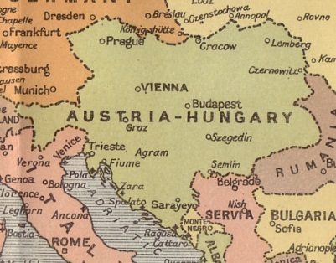 As a result of the unification, Germany became an even bigger producer of manufactured goods and German industry eventually overtook ______________...

*the stage for the future is set!*

**Austria’s Dual Monarchy**

* Since 1848:
  + Result –
* 1867: Emperor Francis Joseph offers a compromise…
  + Dual Monarchy: Solves Magyar nationalists
* Both Separately Have:
* Hungary & Austria Have: